2022-2023 COURSE SYLLABUS
9th Grade Literature and Composition (Honors)

Teacher: Mr. Alex Wallace | Phone Number: (404) 802-3000
Room Number: C-231 | Email: awallace@atlanta.k12.ga.us
Semester: Fall 2022 | Tutorial Days: Fridays
Textbook: My Perspectives (Pearson) | Tutorial Hours:3:45-4:45
Website:https://awallaceela.weebly.com/ | Tutorial Location: C231/Zoom Link

Course Description:
Ninth Grade Literature and Composition is a course study that engages students in a varied exploration of humanities through the modes of reading, writing, grammar and usage, and speaking and listening. While studying long and short works of fiction and nonfiction, poetry, drama, and the epic, students will think and discuss critically and constructively while becoming familiar with literary elements and techniques. In addition, students will write creative pieces of fiction and poetry along with expository papers using a process of writing. These writings will establish knowledge of standard grammar and usage as well as a sense of audience. Further, students will engage in speaking and exercise listening skills through active discussion and oral presentations.
Prerequisite: 8th Grade ELA
By the end of this course, each student will have achieved the Georgia Performance Standards of Excellence for reading, speaking and listening, language, and writing according to their grade level. These standards can be found on the following website:
https://www.georgiastandards.org/Georgia-Standards/Pages/ELA.aspx
Additionally, the course will follow the Georgia Program Standards for Gifted and High Ability Learners as listed below.
- Advanced Communication Skills: Learners will engage in diverse and authentic learning experiences that will allow them to develop and apply innovative oral, written, visual, and nonverbal communication skills across disciplines.
- Creativity (CRT): Learners will generate and/or produce items, ideas, and solutions using creative thinking skills.
- Creative Problem Solving (CPS): Learners will insightfully evaluate a variety of problems and arrive at innovative conclusions.
- Leadership (LEAD): Students will develop an awareness of leadership skills, analyze and evaluate components of leadership, and demonstrate an effective leadership style.
- Higher Order Thinking Skills (HOTS): Learners will analytically critique a system or set of complex ideas, utilizing logic and reasoning skills in novel ways, to create and/or modify knowledge.
- Global Citizenship (GCZ): Learners will develop an awareness of global cultures, connections and issues in order to become actively engaged citizens of the world, with respect for differing values and goals.
- Advanced Research Skills: Learners will gather, decipher, and deter mine credibility of information from a variety of sources and integrate information through analysis of content.
- Social Emotional Learning (SEL): Learners will develop an understanding of their unique social emotional needs as a gifted learner and develop their coping and social interaction skills.
Course Outline:
Weeks 1- Week 9 | Unit 1: American Voices  Our introductory Ninth Grade Literature and Composition unit aims to develop a foundation for a rich and rigorous introductory high school academic experience. Organized around the theme of “American Voices.” Students will explore different aspects of what it means to be American.
Weeks 10- Week 18 | Unit 2: Survival  Throughout the unit, the lessons will connect students to the timeless themes of survival, society versus the individual, and the savagery possible in human nature. Students will explore different kinds of survival-physical, emotional, and mental.
Weeks 1- Week 9 | Unit 3: The Literature of the Civil Rights  Throughout the unit, you will deepen your perspective of the literature of civil rights by reading, writing, speaking, presenting, and listening. These goals will help you succeed on the Unit Performance-Based Assessment.
Weeks 10- Week 18 | Unit 4: Star-Crossed Romances  Whether it means defying a family feud or a civil war, people have had to face incredible challenges to be with their true loves. When there are tragic outcomes, questions about who or what is responsible can be painful. This unit has been designed to allow you to explore a range of star-crossed romances - both fictional and real. As you read, you will examine the conflicts between destiny and personal choice. The recommended text for this unit is William Shakespeare’s Romeo and Juliet.

Evaluation and Grading:

Course Components | Weights | Grading Scale  100-90 A  89-80 B  79-70 C  69-0 F  Not Evaluated NE
Classwork and Participation | 35%
Unit Tests/Writing Assignments Performance | 25%
Lesson Quizzes | 15%
Projects | 15%
Homework | 10%
TOTAL | 100%
Campus Portal for Parents and Guardians: Visit - https://ic.apsk12.org/portal to view class schedules, attendance records and grades. To activate your account, visit the school to receive your login (activation key).
Schoology is a K-12 educational learning management system and an all-in-one platform for teaching, learning, assessing, and reporting grades and data. The goal for an LMS is to allow a school to have a central piece of technology to be the platform for communicating with students, teachers, families, and administration. Students access Schoology through MyBackpack.

Required Materials:

Electronic device with internet access, head phones, disinfecting wipes, hand sanitizer, 1”-2” Binder - Notebook paper – Color Pencils- 5 Dividers -Writing Utensils (Black/blue pens or pencils, etc.

School-wide Behavioral Expectations: No Cell Phone usage during instructional time! Be present; be respectful; be responsible; be on task; be peaceful, productive problem solvers.

Classroom Expectations:
●Come prepared with all required materials and due assignments.
●Cell phones are NOT allowed during instructional time.
●Be present. This includes class participation, active listening, and limiting the use of phones.
●Have respect. Students should treat others as they would like to be treated.
LATE ASSIGNMENTS: (late assignments or unexcused absences): It is important that students are responsible and meet established due dates for assignments. A late assignment is defined as work submitted after the teacher collected the assignment. All missing/not turned in assignments will be recorded in IC with an “M-Missing” designation.

Students with late assignments or unexcused absences must submit missed work within two weeks of the end of the grading periods. The deadlines for missing assignments are as follows:

▪ Midterm is September 30th. Deadline September 23rd (for assignments due August 1st-Sept. 23rd). Assignments submitted late from August 1st through October 7th will be assessed a 20% late penalty.

▪ End of Semester is December 15th. Deadline is December 2nd (for assignments due September 19th-December 2nd). Assignments submitted late from December 5th will be assessed a 20% late penalty and must be submitted by December 14th.

▪ Midterm is March 17th. Deadline is March 3rd (for assignments due January 3rd-March 3rd). Assignments submitted late from January 3rd through March 17th will be assessed a 20% late penalty.

▪ End of Semester is May 26th. Deadline is May 12th (for assignments due February 27th through May 12th). Assignments submitted late from May 15th will be assessed a 20% late penalty and must be submitted by May 24th.

As noted above, all missing/not turned in assignments will be recorded in Infinite Campus with an "M-Missing" designation.

Late assignments will be assessed a 20% penalty.

REASSESSMENT OPPORTUNITY: Reassessment opportunities are available for all students on tests when they scored 69% or below. There will be only one reassessment opportunity on tests. This reassessment will be a newly generated teacher assessment and the reassessment score will replace the original score.

▪ For classes with content on Edgenuity: If the student has not demonstrated mastery of the content during the reassessment opportunity, the student will be assigned Edgenuity. The student must take the assessments in a teacher-proctored environment. Courses aligned with Edgenuity:

▪ Social Studies: World History, US History, Economics, American Government

▪ Language Arts: American Literature, Ninth Grade Literature, World Literature, British Literature

▪ Math: Algebra, Geometry, Advanced Algebra, Pre-Calculus

▪ Science: Biology, Environmental Science, Chemistry, Physics

MAKE-UP ASSIGNMENTS (Excused Absences): Students with an excused absence will be expected to submit missed work on or before the third-class meeting after the absence. Pre-announced assignments are due upon return to school.

MISSED ASSESSMENTS: If a student has missed an assessment due to absence, the student must take the assessment within a week of the student’s return to school. Teachers will use their professional judgment regarding the makeup assessment if the student has been absent for a more extended period.

School-wide Expectations:

MASTERY LEARNING: With mastery learning, a unit of material is taught, and student understanding is evaluated before students are able to move on to the next unit. Students who have not shown mastery for a particular unit will receive feedback and support in reaching mastery. They may be given practice exercises, study guides, group work or complementary resources to help them improve and achieve mastery. Students who demonstrate mastery of the content for a particular unit are given enrichment exercises like special projects, tasks or academic games to further or broaden their knowledge of the material.

For additional help, Tutor ATL info: https://tutoratl.org

PROGRESS REPORTS: Parents and guardians are informed when students are making unsatisfactory progress in classes. Poor performance will be reported to parents and guardians as soon as problems are evident. Progress reports with plans for remediation will be provided for all students making unsatisfactory progress, and parent-guardians conferences must be scheduled. Unsatisfactory grades should never come as a surprise to parents, guardians, or students. Also, see Board Policy Administrative Regulation IHA-R(1) under “Students in danger of not meeting academic expectations” for further information. Teachers will:

- Contact parents/guardians early in the semester if academic, attendance, or behavioral difficulties are apparent.
- Notify the counselor, Student Support Team (SST)/Response to Intervention (RTI) Chair, and/or an assistant principal of serious problems that are affecting classroom performance.
- Set up parent conferences as necessary.

ATHLETIC ELIGIBILITY: Students wanting to participate in athletic programs governed by the GHSA and extracurricular activities must meet eligibility requirements to participate. The Athletic Director (and the Extracurricular Activities sponsors) will collaborate with teachers to monitor and to identify students in danger of failing courses. A master list of students participating in extracurricular activities and athletics under the auspices of the GHSA will be available to all staff.

Our Vision: A high-performing school where educators inspire, families engage and students love to learn.
Our Mission: Every student will graduate college and career ready with a dedication to community involvement and service.
Midtown Graduate Profile (5 Cs): Creative, collaborative, critical thinker, communicative, and a good citizen.
For Mental Health Crisis you may call the Georgia Crisis & Access Line at 1-800-715-4225.
Resources:
https://suicidepreventionlifeline.org/
https://namiga.org/georgia-crisis-and-access-line/
https://www.crisistextline.org

See Something Say Something Anonymous Line: 1-844-5-SAYNOW

School Counseling Site for Resources/Documents: https://www.atlantapublicschools.us/Page/46013
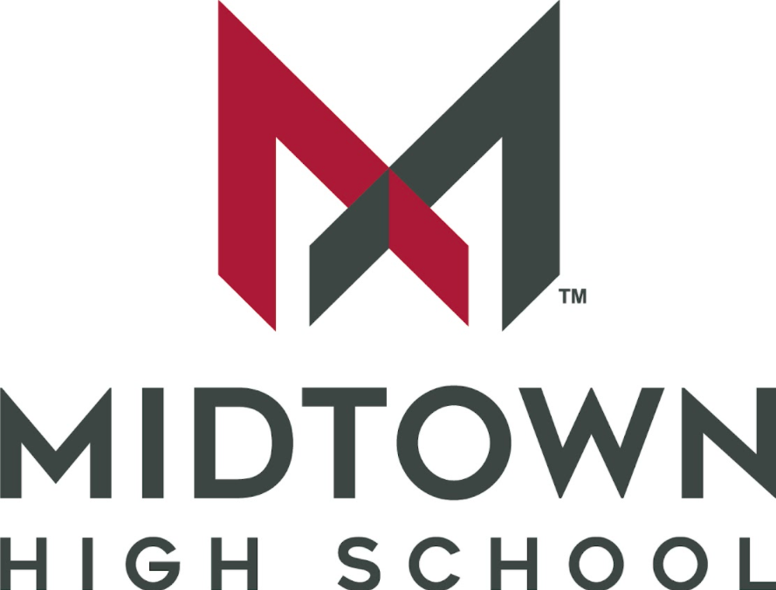

Receipt of Syllabus
Course Name: 9th Grade Literature and Composition (Honors)
Teacher Name: Mr. Alex Wallace

______________________________ __________________________________
Student Signature Parent/Guardian Signature

______________________________ __________________________________
Date Date

